LAB 2: Rectifiers and Filters

**Reg.# ______________ Date: ______________**

## OBJECTIVES:

## To implement a half wave rectifier.

## To implement a full-wave rectifier.

## To study the effect of filter capacitors on rectifier output.

## SUGGESTED READING:

* [Chapter 3: “Diode Applications”, *introductory Electronic Devices and Circuits by Paynter.*](http://arduino.cc/en/Guide/HomePage)
* Datasheet : 1N4007 rectifier diode

## EQUIPMENT AND COMPONENTS:

* Basic Circuits Training Board
* 1N4007 Rectifier Diode
* Light Emitting Diode
* Jumper Wires
* Scope / DMM
* Electrolyte Capacitors (1uF, 2.2uF, 10uF, 100uF)
* Voltage Transformer

---------------------------------------------------------------------------------------------------------------------

## Rectification:

Rectification is a process of converting AC signals into DC signals. Rectification can be performed using diodes in series with the voltage source. There are two main types of diode rectifiers:

- Half-wave rectifiers

- Full-wave rectifiers

## Half Wave Rectifiers:

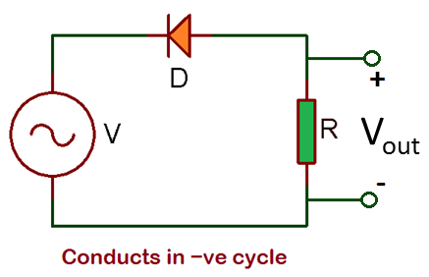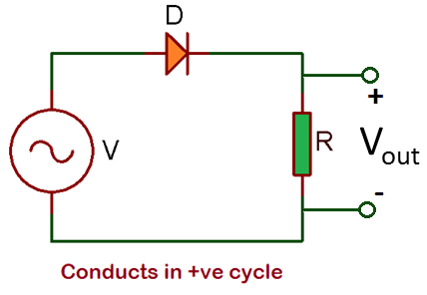

Fig 3.1: Half Wave Rectifier

A single diode connected in series with an AC voltage source forms a half-wave rectifier (Fig 3.1). The diode conducts only positive or only negative half cycle, depending on its orientation in the circuit (Fig 3.2).

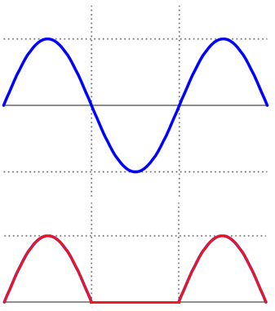

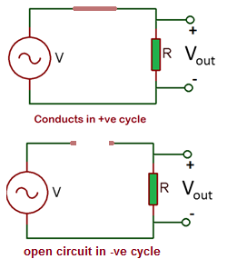

Fig 3.2: Half Wave Rectifier Output

The output of a half-wave rectifier is described by:

* VAV = Vmax/π

$VRMS = Vmax/\sqrt{2}$

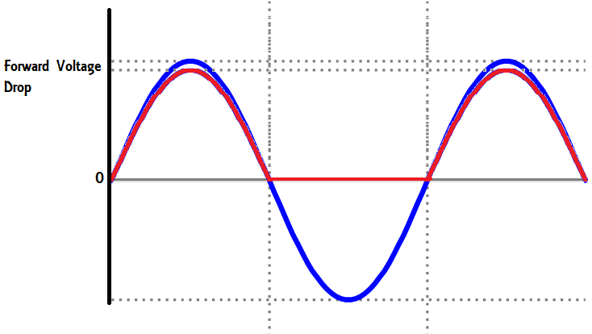

## Full Wave Bridge Rectifier:

Full-wave rectifiers can be made using four diodes in a bridge configuration (Fig 3.3).

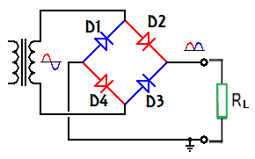

Fig 3.3: Full Wave Bridge Rectifier

The bridge rectifiers are the most commonly used bridge rectifiers due to high average output and fewer variations in output.

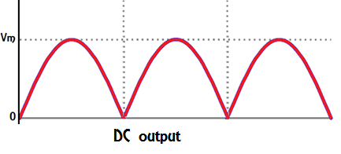

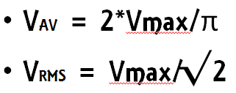

## Procedure:

TASK1:

* Connect one rectifier in series with the AC output from the 12V transformer to make the positive half-wave rectifier.
* Using scope view the input and output signals and record the maximum value of the output.
* Connect the diode in opposite polarity to make the negative half-wave rectifier and record the maximum value of the output.

TASK2:

* Connect four diodes in the bridge configuration:

## 

* Analyze the output by viewing it via palm-scope.
* Record the maximum value of the output.
* Repeat the process and record the values of input voltage, output voltage, the current through the diode, and current through the load.

TASK3:

* Re-connect the circuit in half-wave diode rectifier configuration.
* Connect a small (1uF) capacitor with the output and observe the effect of the capacitor on the output.
* Connect increasingly larger values of capacitors and observe their effects on the rectifier outputs.
* Now vary the load resistance and observe the effects on the rectifier output.

## REVIEW QUESTIONS:

Q: What rectifier would you prefer to use, and why?

Ans:

Q: Write down the average and RMS values of both rectifier outputs.

Ans:

Q: Describe the effects of filter capacitance on the rectifier output.

Ans:

Q: Can the bridge rectifier be used to generate negative voltages? Explain using figure.

Ans:

Q**:** Plot two periods of your output (approximated) of half-wave rectifier using MS Excel.

Assignment

***Design a model of the half-wave rectifier and full-wave rectifier.***

Rectifier (diode capacitor, load resistance)

Input voltage (reg.#)

Scope (four terminals)

Input waveform

Voltage after rectifier

Voltage after capacitor

Current waveform

Print this circuit and calculate (by hand) average voltage, peak voltage, ripple factor, inverse peak voltage.

Make a pdf and send it on WhatsApp.